Table 1.

Task Interdependence – the degree to which taskwork is designed so that members depend upon one another for access to critical resources and create workflows that require coordinated action

* *Note: Example items in italics*

|  |  |  |
| --- | --- | --- |
|  | Interdependence Type | Level |
| Morgeson & Humphrey, 2006 (A)   * *The job requires me to accomplish my job before others complete their job* * *Unless my job gets done, other jobs cannot be completed* | Initiated | Individual |
| Morgeson & Humphrey, 2006 (B)   * *The job depends on the work of many different people for its completion* * *My job cannot be done unless others do their work* | Received | Individual |
| Liden, Wayne, & Bradway, 1997   * *Group members frequently must coordinate their efforts with each other* * *The way individual members perform their jobs has significant impact upon others in the group* | Mix | Team |
| Pearce & Gregersen, 1991 (A)   * *The way I perform my job has a significant impact on others* * *My own performance is dependent on receiving accurate information from others* | Reciprocal | Individual |
| Pearce & Gregersen, 1991 (B)   * *I work fairly independently of others in my work* * *I can plan my own work with little need to coordinate with others* | Independent | Individual |
| Mohr, 1971   * *Mine is pretty much a one-person job; there is little need for checking or working with others* | Mix | Individual |
| Pennings, 1975   * *Dependent on others for advice and other decisional inputs* | Mix | Individual |
| Lee, Shin, & Ki, 2018   * *I cannot accomplish my tasks without information or materials from other members of my team* * *Within my team, jobs performed by team members are related to one another* | Mix | Mix |
| Campion, Medsker, & Higgs, 1993   * *I cannot accomplish my tasks without information or materials from other members of my team* * *Other members of my team depend on me for information or materials needed to perform their tasks* | Reciprocal | Mix |
| Wong & Campion, 1991   * *How well one task is performed has a great effect on how well the other task can be performed* * *One task needs to be performed before the other task* | Reciprocal | Individual |

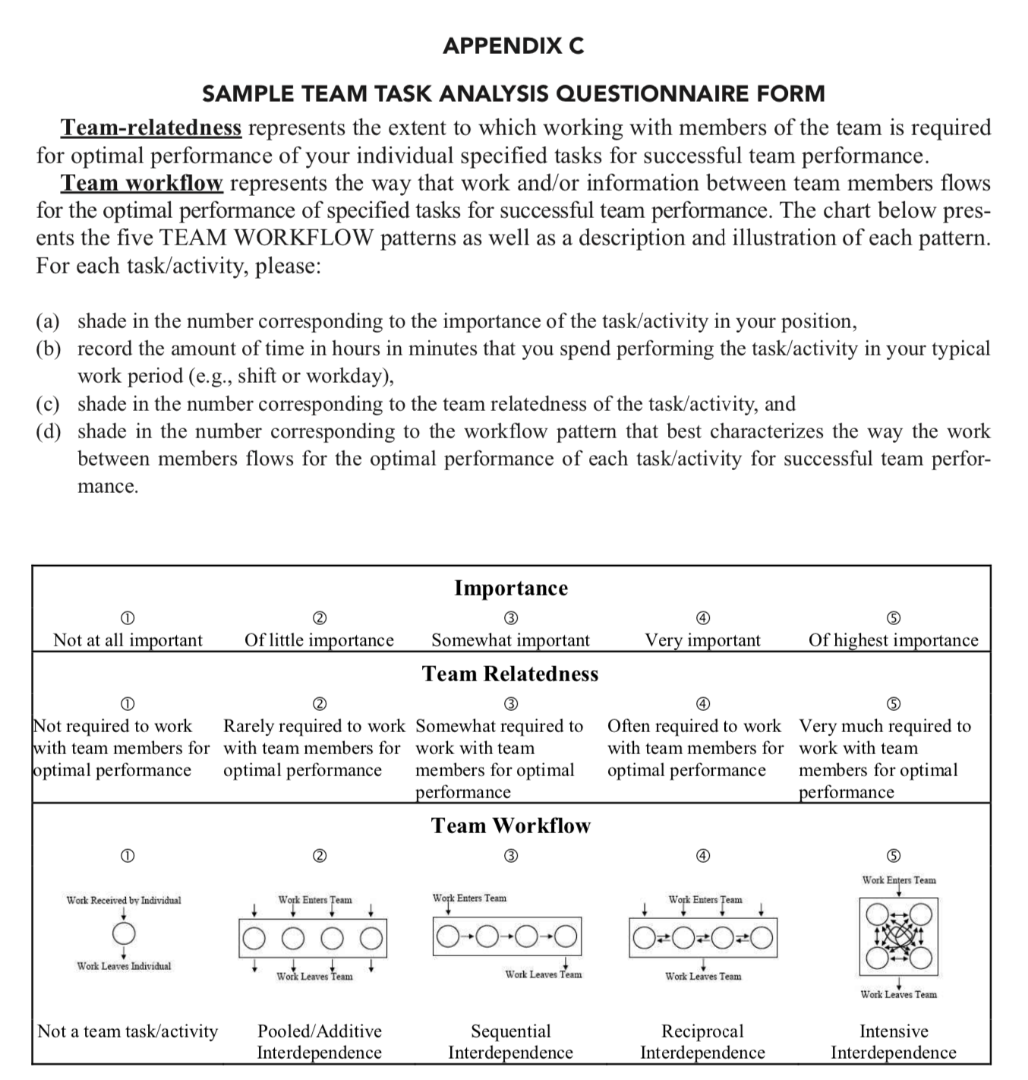

*Figure 1.* Arthur et al.’s (2012) task interdependence questionnaire based on individual tasks.

Indicate what percent of the total work within your unit flows in each of the ways shown by the respective figure…

1. Independent work flow



… where work and activities are performed by your immediate subordinates independently and do not flow between them (give percent)

1. Sequential work flow



… where work and activities flow between your immediate subordinates, but only in one direction (give percent)

1. Reciprocal work flow



… where work and activities flow between your immediate subordinates in a reciprocal “back and forth” manner over a period of time (give percent)

1. Team work flow



… where work and activities come into your unit and your immediate subordinates diagnose, problem-solve, and collaborate as a group at the same time to deal with the work (give percent)

*Figure 2.* Workflow questions presented by Van de Ven et al. (1976) and Thompson (1967).

Table 2.

Outcome Interdependence – the degree to which the outcomes of taskwork are measured, rewarded, and communicated so as to emphasize collective outputs rather than individual contributions

* *Note: Example items in italics*

|  |  |  |
| --- | --- | --- |
|  | Interdependence Type | Level |
| Janssen, Vliert, & Veenstra, 1999   * *Benefits for one team member involved benefits for others* * *Gain for one team member meant gain for others* | Mix | Team |
| De Dreu, Carsten, & West, 2001   * *When one or more team members excel in their work, I benefit from that* | Reward | Individual |
| Zhang, Tjosvold, & Hempel, 2007   * *The goals of team members go together* * *When our team members work together, they usually have common goals* | Goal | Team |
| Campion, Medsker, & Higgs, 1993 (A)   * *My work goals come directly from the goals of my team* * *My work activities for a given day are determined by my team’s goals for that day* | Goal | Individual |
| Campion, Medsker, & Higgs, 1993 (B)   * *Many rewards from my job are determined in large part by my contributions as a team member* * *My performance evaluation is strongly influenced by how well my team performs* | Reward | Individual |

Table 3.

Structural Interdependence Indices

|  |  |  |
| --- | --- | --- |
|  | Interdependence Type | Level |
| O’Brien, 1968 – Intertask Coordination  Wood, 1986 – Coordinative Complexity  Oeser & O’Brien, 1967 – Task x Task Matrix   * *Purpose: index the extent of precedence relationships among tasks* | Task | Either |



|  |  |
| --- | --- |
| Value | |
| 10 | 3 |

|  |  |  |
| --- | --- | --- |
|  | Interdependence Type | Level |
| O’Brien, 1968 – Interposition Collaboration  Oeser & Frank, 1962, 1964 – Person x Task Matrix   * *Purpose: index the extent to which people work jointly on tasks* | Task | Either |

**

|  |  |
| --- | --- |
| Value | |
| 0 | 0.5 |

Table 3 continued.

|  |  |  |
| --- | --- | --- |
|  | Interdependence Type | Level |
| Lenox, Rockart, & Lewin, 2007 – NK Model of Interdependence   * *Purpose: index the increasing number of potential results as tasks become dependent on one another* | Other | Either |

* Example
  + Task (or activity) A depends on B = 4 potential results
  + Task (or activity) A depends on B and C = 8 potential results
  + Task (or activity) A depends on B and C and D = 16 potential results
    - Potential results = 2N where *N* = the number of dependent tasks

|  |  |  |
| --- | --- | --- |
|  |  |  |
| Syntactic Dependency   * *Purpose: index the number of instances where a script references code from another script* | Task | Either |

* Example
  + In script A, I reference data or objects or functions from 3 other scripts
  + In script B, I reference data or objects or functions from 8 other scripts
    - Script A has greater syntactic dependency than B

|  |  |  |
| --- | --- | --- |
|  |  |  |
| Workflow Dependency   * *Purpose: index the degree centrality of the most central individual that works on a script* | Task | Either |

* Example
  + Bobby (degree centrality = 5), Susan (1), and Jill (2) work on script A
  + John (3), Jackie (2), Bill (4), and Roger (1) work on script B
    - Script A has greater workflow dependency than Script B

|  |  |  |
| --- | --- | --- |
|  |  |  |
| Logical Dependency   * *Purpose: index the extent to which a file requires other files to be modified during the same commit* | Task | Either |

* Example
  + During commit “Morning,” John works on file A which also requires him to work on files B and C
  + During commit “Afternoon,” John works on file M which is not dependent on any other files
    - File A has greater logical dependence than file M
    - Or, is it…commit “Morning” has greater logical dependence than commit “Afternoon”

Table 3 continued.

|  |  |  |
| --- | --- | --- |
|  | Interdependence Type | Level |
| Victor & Blackburn, 1987 – Index of Dependence   * *Purpose: index the extent to which rewards are determined by other player’s actions (tasks) rather than one’s own* | Outcome | Individual |



|  |  |
| --- | --- |
| Value | |
| Index for player A = 1 (outcomes are completely determined by other player’s actions (tasks)) | Index for player B = 0.33 |

|  |  |  |
| --- | --- | --- |
|  |  |  |
| Victor & Blackburn, 1987 – Index of Correspondence   * *Purpose: index the extent to which, across the team, rewards determined by an individual’s own actions (tasks) are aligned with rewards determined by other’s actions (tasks)* | Outcome | Team |